25th July 2018

**Success for YOKOHAMA Italy Rally Experience for customers**

YOKOHAMA Italy recently invited a select group of YOKOHAMA customers to take part in an exclusive rally event: The YOKOHAMA Rally Experience. Alongside the driver Alessandro Bettega driving a powerful Peugeot 208 R5 of the Munaretto Team, guests ran a real special Rally test under extreme conditions. The pilot from Trentino Alto Adige did not spare any efforts and displaying the full power of the 208 and thrilled every brave co-driver.

The test took place in the splendid countryside setting in the area of Lonato del Garda, in the province of Brescia, near La Quiete park. Over 4 kilometres of dirt road that represents for many pilots a privileged location for testing. A land often used by Italian rally champions, who know the place as a training course.

The event was organised to reward the most loyal YOKOHAMA Italia customers and for those who achieved significant results in the first half of the year. YOKOHAMA Italy expressed its gratitude for the efforts and hard work conducted by the guests and offered them a truly unique experience and letting them also try the rally racing tyre models produced by the YOKOHAMA Rubber Company. "Both the A036 and the A053 tyres were used, given the changing weather conditions during the day" - explains Giuseppe Pezzaioli, Head of Motorsport at Yokohama Italia - "In the morning it rained, to the delight of the pilot who could "put sideways" the Peugeot on a more slippery and fun ground, while in the afternoon a drier soil allowed top speeds." "A decidedly successful event" - affirms Marco Princigalli, Sales Director of Yokohama Italia - "On one hand, the Clients have been able to experience a unique experience, on the other it was an opportunity to discuss the business and the mutual commercial strategies. For some, it was also an opportunity to visit our headquarters for the first time and discover the value added services offered by our company.

<https://vimeo.com/pressplayit/yokohama-rally-experience>

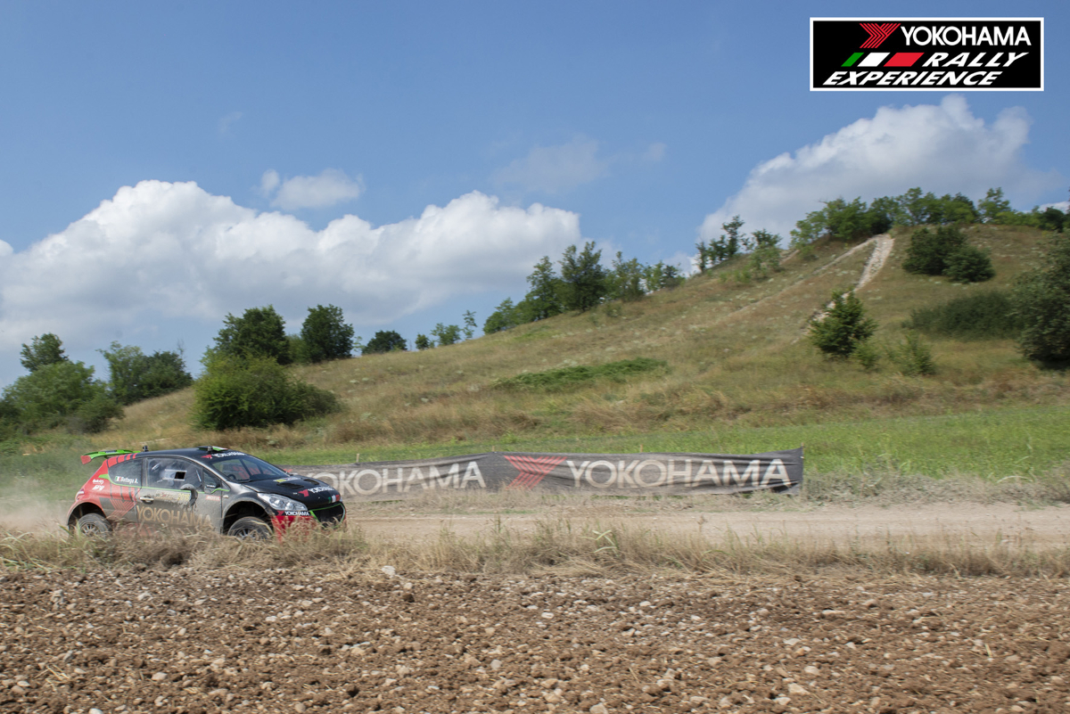

*Yokohama Rally Experience*

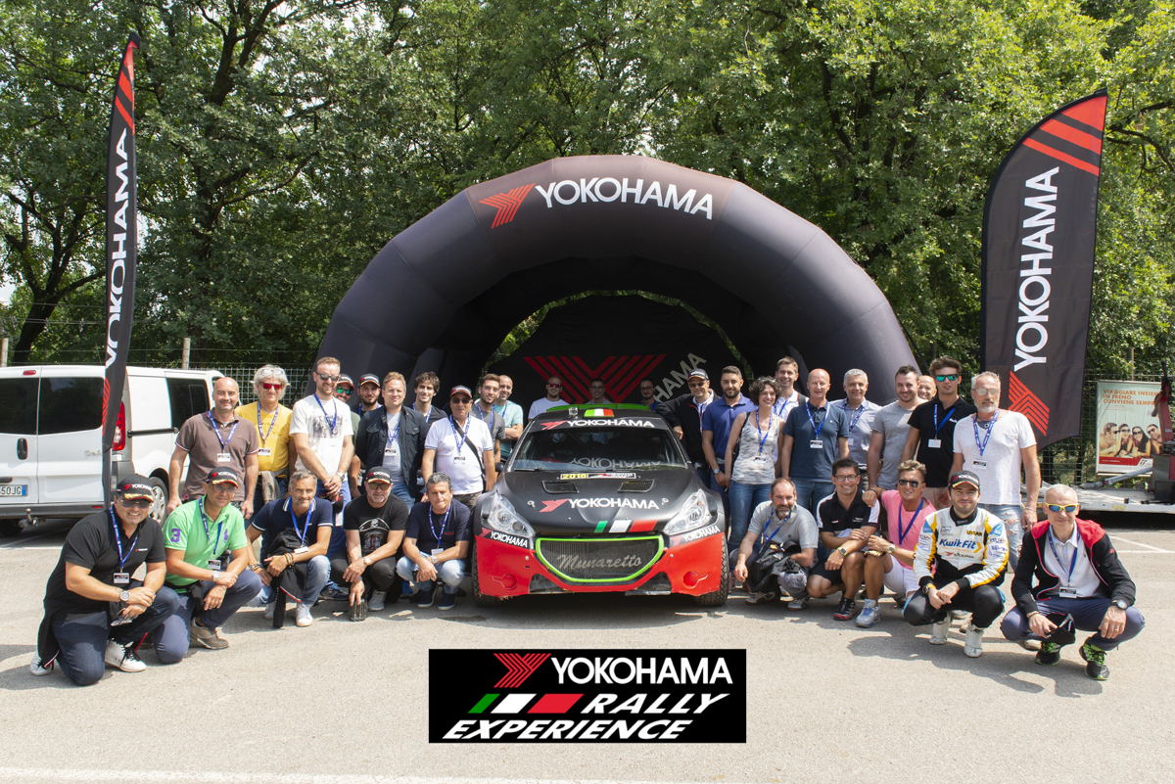

*Yokohama Rally Experience 2*